90.06.00c
To the Gardeners' Chronicle

[A musa bearing its fruits erect at the top of its stem is decidedly unusual. Generally the great weight of the fruit causes the stem to bend downwards, but in this Fijian species such is the stiffness of the stem that the fruits are borne erect, whence, probably, the name Uranoscopa — heaven regarding — which was applied to a similar species by Rumphius, and to this particular plant by Seemann, under the erroneous impression that his plant was the same as Rumpf's. Baron Von Mueller, K.C.M.G., however, recognised the difference, and in his Fragmenta, ix., 190, has given the name M. Seemanni to this species. The photograph whence our illustration was taken was sent to us by Baron Von Mueller, who received it from H.E. Sir John Thurston, the Governor of the Fiji Islands (see fig. 28).]

Musa Seemanni
Musa uranoscopa

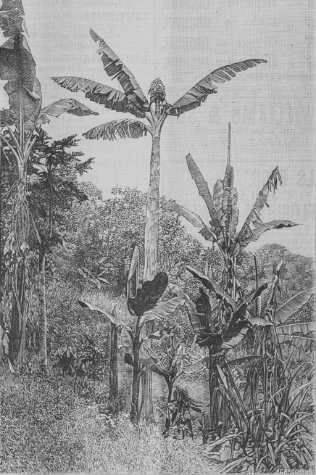

Letter not found. The text given here is from 'Musa seemanni', Gardeners' chronicle, 16 August 1890, pp. 182-3. It is dated to June as the latest likely date that it could have been sent to have been reported in this issue.
The baptismal surname of Rumphius (TL2).
B75.12.01.
90-06-00c_image01.jpg The illustration is captioned 'musa seemannii. from a photograph of his excellency sir john thurston, governor of the fiji island'. M had asked Thurston some years earlier for photographs of a Musa; see J. Thurston to M, 1886 (in this edition as 86-00-00), but it is probable that a more recent request had been made. It is also, however, possible that Thurston's increased responsibilities leading up to his becoming Governor of Fiji in 1888 may have reduced the time available for his botanical photography.

